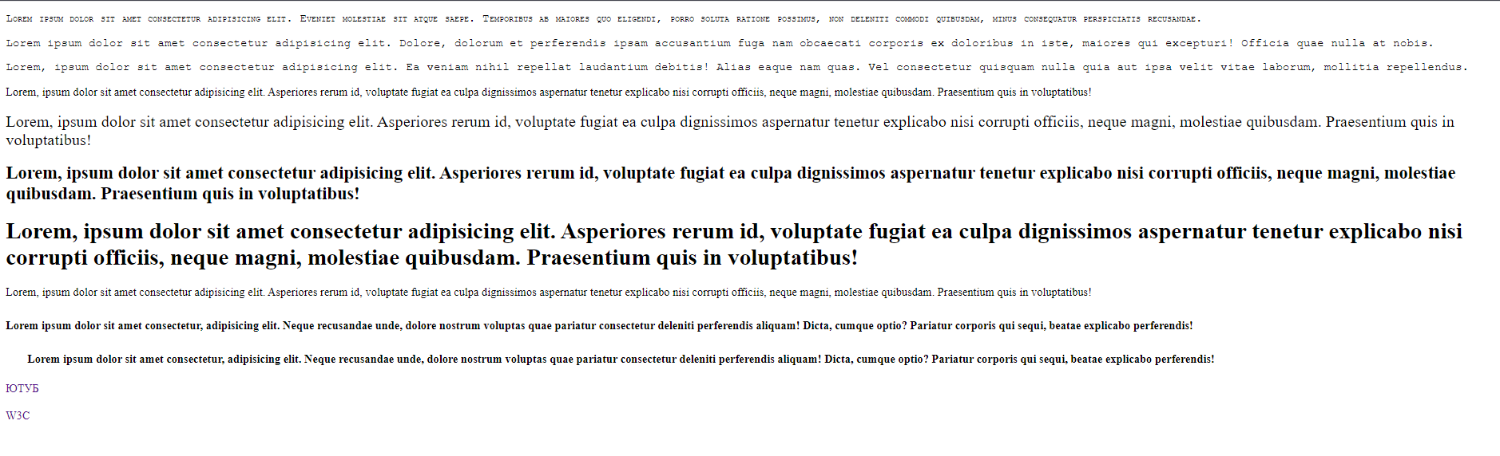

<!DOCTYPE html>

<html lang="ru">

<head>

    <meta charset="UTF-8">

    <meta http-equiv="X-UA-Compatible" content="IE=edge">

    <meta name="viewport" content="width=device-width, initial-scale=1.0">

    <title>Document</title>

    <link rel="stylesheet" href="styles/style.css">

</head>

<body>

    <p id="kapit"> Lorem ipsum dolor sit amet consectetur adipisicing elit. Eveniet molestiae sit atque saepe.

        Temporibus ab maiores quo eligendi, porro soluta ratione possimus, non deleniti commodi quibusdam, minus

        consequatur perspiciatis recusandae.</p>

    <p id="times"> Lorem ipsum dolor sit amet consectetur adipisicing elit. Dolore, dolorum et perferendis ipsam

        accusantium fuga nam obcaecati corporis ex doloribus in iste, maiores qui excepturi! Officia quae nulla at

        nobis.</p>

    <p id="courier">Lorem, ipsum dolor sit amet consectetur adipisicing elit. Ea veniam nihil repellat laudantium

        debitis! Alias eaque nam quas. Vel consectetur quisquam nulla quia aut ipsa velit vitae laborum, mollitia

        repellendus.</p>

    <div class="normal">Lorem, ipsum dolor sit amet consectetur adipisicing elit. Asperiores rerum id, voluptate fugiat

        ea culpa dignissimos aspernatur tenetur explicabo nisi corrupti officiis, neque magni, molestiae quibusdam.

        Praesentium quis in voluptatibus!</div>

    <br>

    <div class="lighter">Lorem, ipsum dolor sit amet consectetur adipisicing elit. Asperiores rerum id, voluptate fugiat

        ea culpa dignissimos aspernatur tenetur explicabo nisi corrupti officiis, neque magni, molestiae quibusdam.

        Praesentium quis in voluptatibus!</div>

    <br>

    <div class="bold">Lorem, ipsum dolor sit amet consectetur adipisicing elit. Asperiores rerum id, voluptate fugiat ea

        culpa dignissimos aspernatur tenetur explicabo nisi corrupti officiis, neque magni, molestiae quibusdam.

        Praesentium quis in voluptatibus!</div>

    <br>

    <div class="bolder">Lorem, ipsum dolor sit amet consectetur adipisicing elit. Asperiores rerum id, voluptate fugiat

        ea culpa dignissimos aspernatur tenetur explicabo nisi corrupti officiis, neque magni, molestiae quibusdam.

        Praesentium quis in voluptatibus!</div>

    <br>

    <div class="mychoise">Lorem, ipsum dolor sit amet consectetur adipisicing elit. Asperiores rerum id, voluptate

        fugiat ea culpa dignissimos aspernatur tenetur explicabo nisi corrupti officiis, neque magni, molestiae

        quibusdam. Praesentium quis in voluptatibus!</div>

    <br>

    <div class="mychoiseone">Lorem ipsum dolor sit amet consectetur, adipisicing elit. Neque recusandae unde, dolore

        nostrum voluptas quae pariatur consectetur deleniti perferendis aliquam! Dicta, cumque optio? Pariatur corporis

        qui sequi, beatae explicabo perferendis!</div>

    <br>

    <div class="mychoisetwo">Lorem ipsum dolor sit amet consectetur, adipisicing elit. Neque recusandae unde, dolore

        nostrum voluptas quae pariatur consectetur deleniti perferendis aliquam! Dicta, cumque optio? Pariatur corporis

        qui sequi, beatae explicabo perferendis!</div>

    <br>

    <a href="https://www.youtube.com/">Ютуб</a>

    <br><br>

    <a href="https://www.w3.org">W3C</a>

</body>

</html>

p {

    font-family: Courier;

}

#kapit {

    font-variant: small-caps;

}

.normal {

    font-weight: normal;

    font-size: 16px;

    /\* значение 16px установлено по умолчанию для HTML, normal не подходит как значение \*/

}

.lighter {

    font-weight: lighter;

    font-size: 17pt;

}

.bold {

    font-weight: bold;

    font-size: 25px;

}

.bolder {

    font-weight: bolder;

    font-size: 200%;

    line-height: normal;

}

.mychoise {

    font-weight: 300;

    line-height: 1.5;

}

.mychoiseone {

    font-weight: 600;

    line-height: 32px;

}

.mychoisetwo {

    font-weight: 700;

    line-height: 150%;

    text-align: justify;

    text-indent: 30px;

}

a {

    text-decoration: none;

    text-transform: uppercase;

}